Student worksheet

9.1 The Earth, Sun and Moon interact with each other

Pages 156–157 and 211

Earth, Sun and Moon interactions

1 The Sun is central to our existence on Earth – without it we could not survive.

a What is the Sun?

b What does the Sun provide for the Earth?

c How is solar energy created?

d What is the solar system?

e What is one similarity in the interactions between the Earth and the Sun and an asteroid and the Sun?

2 To explain why the Earth experiences daytime and night-time, label the diagram below with the axis, equator and the poles. Also include arrows to indicate the direction of rotation and the Sun’s rays.

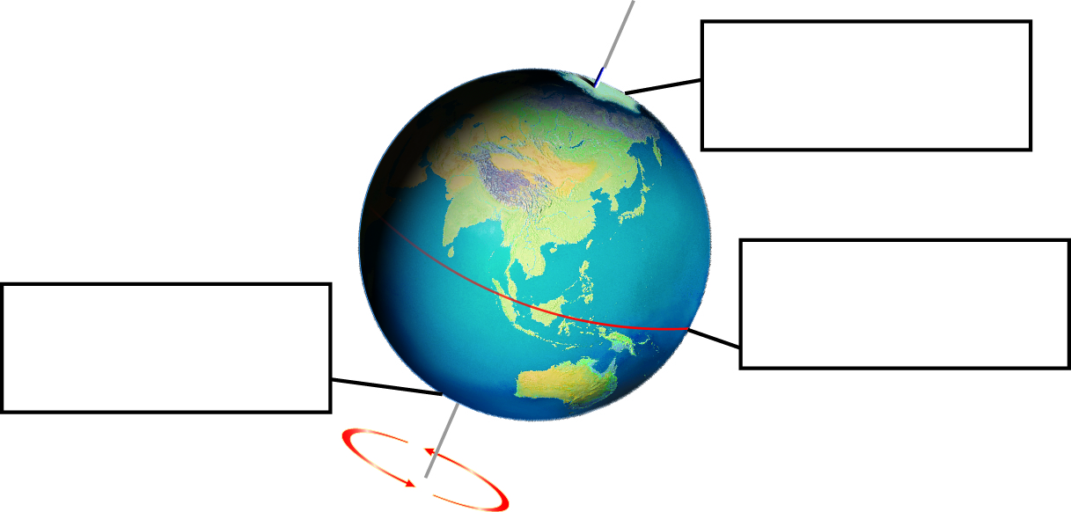

3 Which states of Australia would see sun rise:

a first? ______________________________________________________________

b last? ______________________________________________________________

4 The diagrams below show the position of the Sun, Earth and Moon during a solar and lunar (Moon) eclipse. The lunar eclipse is explained in section 9.2, but before you explore this, complete the following questions:

a What is the position of the Moon during a solar eclipse?

b What is the position of the Moon during a lunar eclipse?

c Would people in the United Kingdom see the same solar eclipse as people in the Western Sahara (north-west coast of Africa)? Explain your answer.

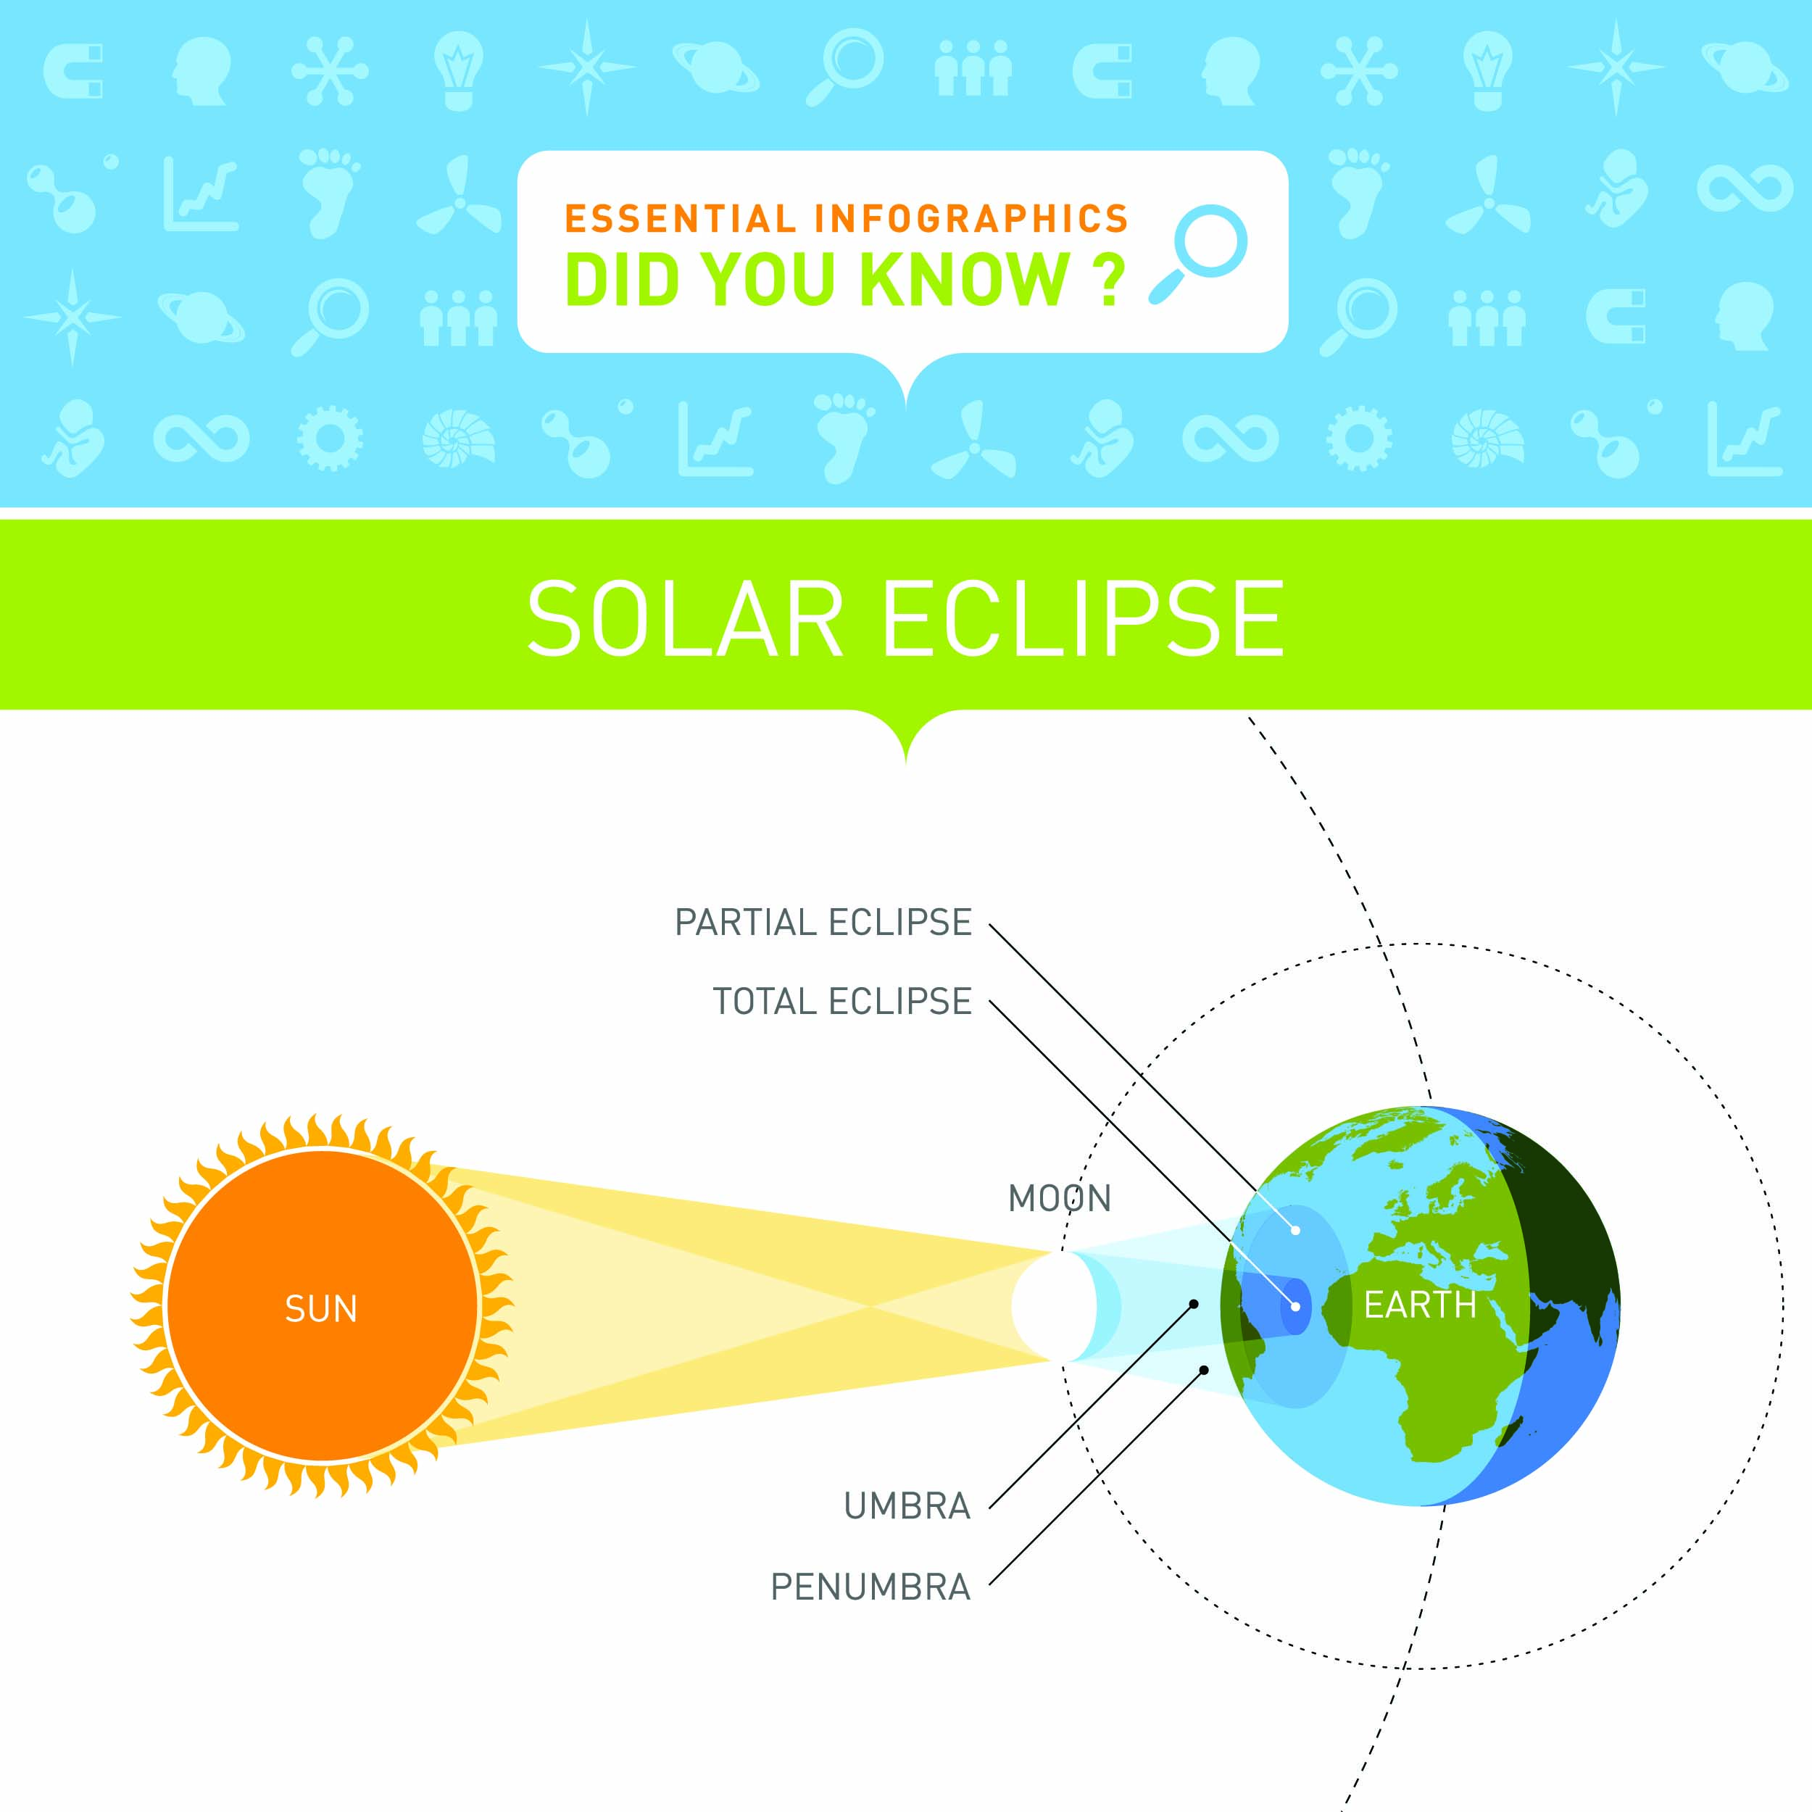 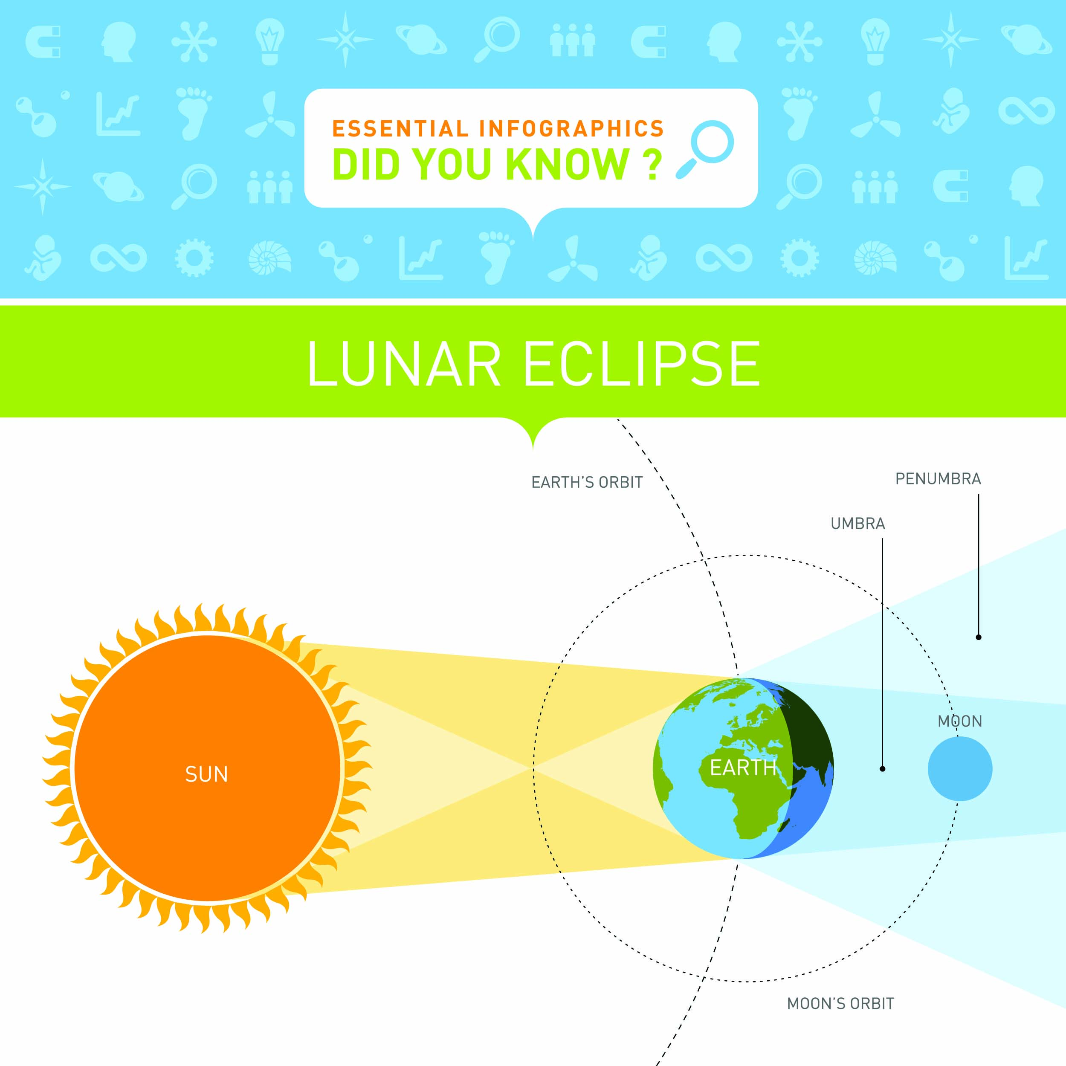

EXTEND YOUR UNDERSTANDING

5 Research on the Internet to find out why looking directly at a solar eclipse can permanently damage your eyes.

Student worksheet

9.2 The Moon reflects the Sun’s light

Pages 158–159 and 212

Phases of the Moon

1 Below is a diagram showing the phases of the moon.

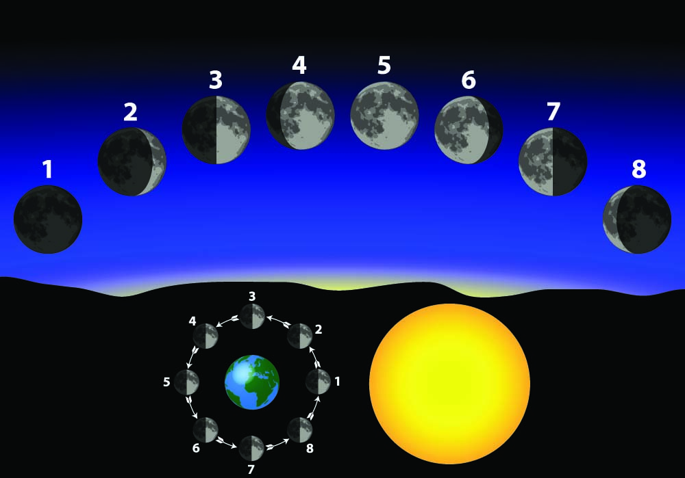

Complete the table below by filling in the phase of the Moon represented by each number in the diagram above.

|  |  |
| --- | --- |
| 1 |  |
| 2 |  |
| 3 |  |
| 4 |  |
| 5 |  |
| 6 |  |
| 7 |  |
| 8 |  |

2 a Why was Galileo Galilei referred to as an astronomer?

b How did Galileo observe the Moon?

c The Moon has large, flat plains called ‘seas’. What ‘active’ feature of the landscape would have created these ‘seas’?

d What happens to the Moon during the daytime?

3 a When did people first land on the Moon? _______________________________________

b Who were the first two people on the Moon?

c Describe the conditions the astronauts experienced on the Moon.

d What special equipment did they wear to cope with the conditions?

EXTEND YOUR UNDERSTANDING

4 Find out when the ‘seas’, large plains of solidified lava, were created on the Moon. Also research what the Earth was like at this time.

Student worksheet

9.3 Seasons are caused by the tilt of the Earth

Pages 160–161 and 212

Seasons

1 Below is a diagram showing the Earth’s rotation around the Sun over the period of a year. There are four Earths, each representing a different season. Fill in the boxes to explain what is happening in Australia when the Earth is in the different positions.

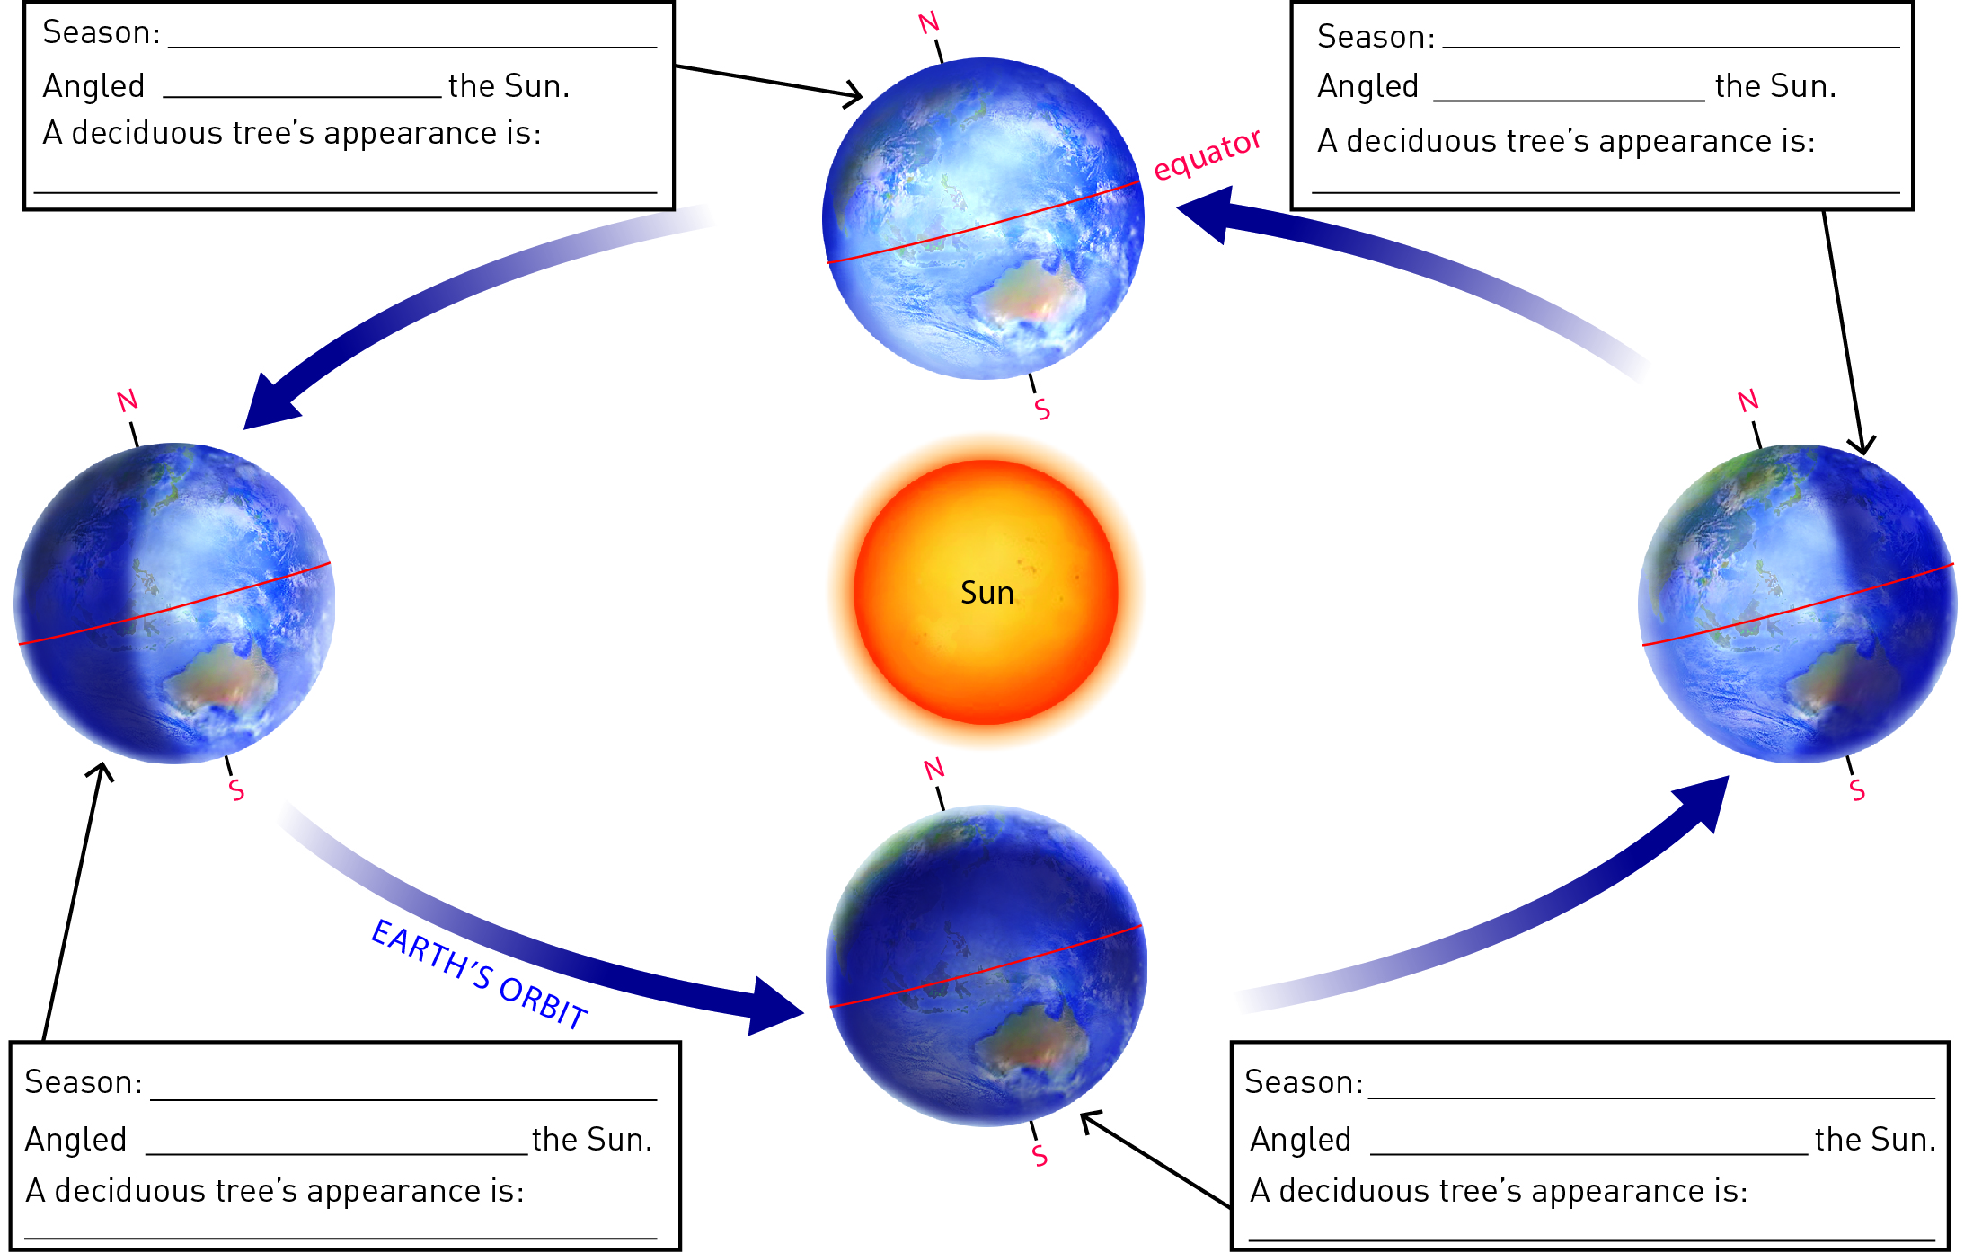

2 What is the equinox?

3 What is a solstice?

4 Below is a diagram showing the Earth’s rotation around the Sun over the period of a year. There are four Earths, each representing a different season. Fill in the boxes to explain what is happening in the United States of America when the Earth is in the different positions.



EXTEND YOUR UNDERSTANDING

5 Use the Internet to discover whether Mars has seasons. If it does:

a how long is each season?

b describe what the conditions are during the Martian summer and winter.

Student worksheet

9.4 Science as a human endeavour: Astronomers explore space

Pages 162–163

Astronomy

1 List four ways that Ancient Astronomers used their observations of the stars, Sun and Moon:

2 What information can be gathered using telescopes?

3 The Hubble Space Telescope observes the universe in more detail than we can from Earth.

a What forms of electromagnetic radiation can be observed by the Hubble Space Telescope?

b Describe what you know or understand about any of these forms of electromagnetic radiation.

4 The image to the right shows an astronaut exploring the surface of Mars. In the background you can see a moon of Mars and also the planet Earth.

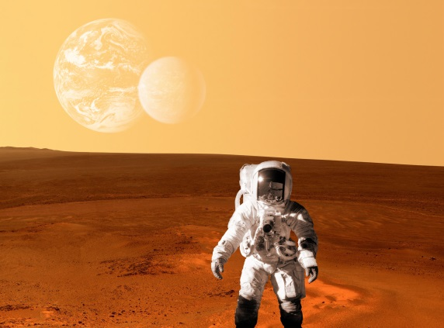

a Is the image real or fake?

b What are some of the factors that helped you reach your conclusion?

c What chemicals were detected by instruments on the *Phoenix* Mars Lander?

EXTEND YOUR UNDERSTANDING

5 Find out what dark matteris and why it cannot be photographed.